**PII ACCESS HISTORY DOCUMENT**

1. In the Governance Database, we have created a Access History table which captures the Users’ access to particular Columns in a table
2. The table has details of which user has accessed which column from which table and how many times it has been accessed.
3. In the below example, it shows the access_count of “EMAIL” column from various tables

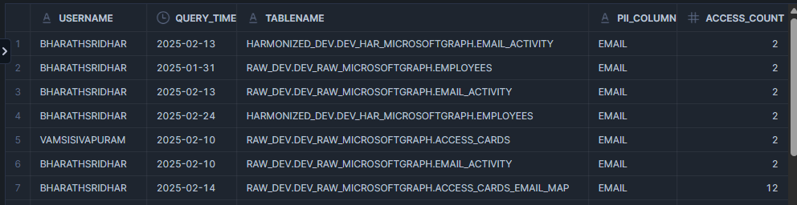

CREATE OR REPLACE PROCEDURE DATADICTIONARY_DEV.DEV_DICTIONARY.PII_ACCESS_HISTORY_PROC()

RETURNS VARCHAR(500)

LANGUAGE SQL

EXECUTE AS OWNER

AS '

BEGIN

TRUNCATE TABLE DATADICTIONARY_DEV.DEV_DICTIONARY.PII_ACCESS_HISTORY;

INSERT INTO DATADICTIONARY_DEV.DEV_DICTIONARY.PII_ACCESS_HISTORY(

USERNAME,

QUERY_TIME,

TABLENAME,

PII_COLUMN,

ACCESS_COUNT

)

WITH PII_Access_History AS(

SELECT

user_name,

query_start_time,

base_accessed.value:objectName as object_name,

base_accessed_final.value:columnName as columnlist

FROM

snowflake.account_usage.access_history,

lateral flatten(input => access_history.base_objects_accessed) as base_accessed,

lateral flatten(input => base_accessed.value:columns) as base_accessed_final,

WHERE columnlist = ''EMAIL''

UNION ALL

SELECT

user_name,

query_start_time,

direct_accessed.value:objectName as object_name,

direct_accessed_final.value:columnName as columnlist

FROM

snowflake.account_usage.access_history,

lateral flatten(input => access_history.direct_objects_accessed) as direct_accessed,

lateral flatten(input => direct_accessed.value:columns) as direct_accessed_final,

WHERE columnlist = ''EMAIL''

)

SELECT

user_name,

TO_DATE(query_start_time),

object_name,

columnlist,

COUNT(*) AS access_count

FROM

PII_Access_History

GROUP BY

user_name, object_name,columnlist,TO_DATE(query_start_time)

ORDER BY

access_count DESC;

RETURN ''Procedure Executed Successfully'';

END;

';

